**Blood donation drive database**

Start mysql service on system

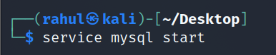

Start MYSQL Database

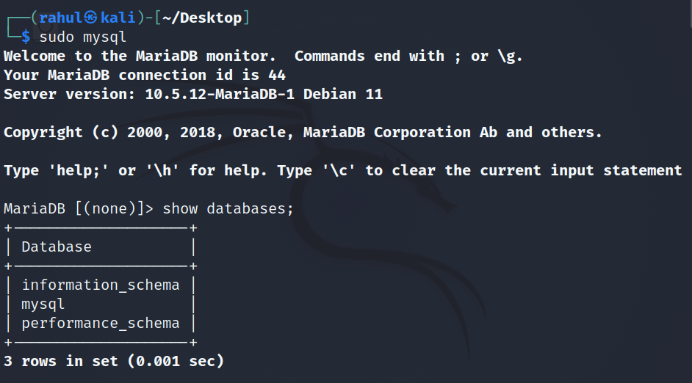

To check database

**Show databases;**

Create new database

**Create database blood_donation;**

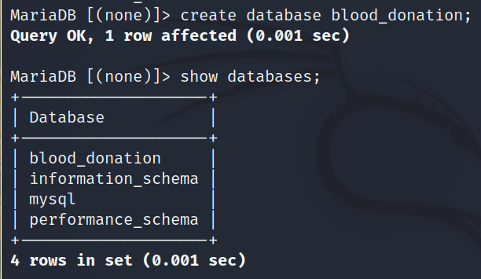

**To use new create database**

Use blood_donation

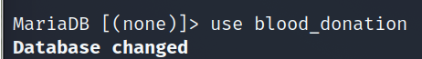

**Create tables and columns**

Create table donors

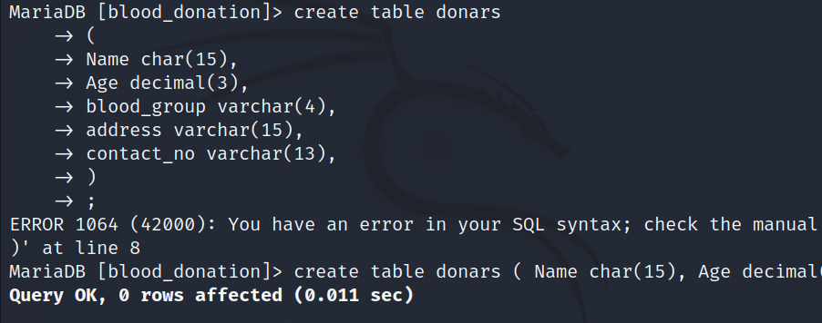

**To check created table**s

Show tables;

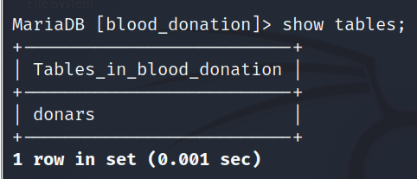

**Now we have to insert values in tables donor**s

Insert into donors values(“”,””,);

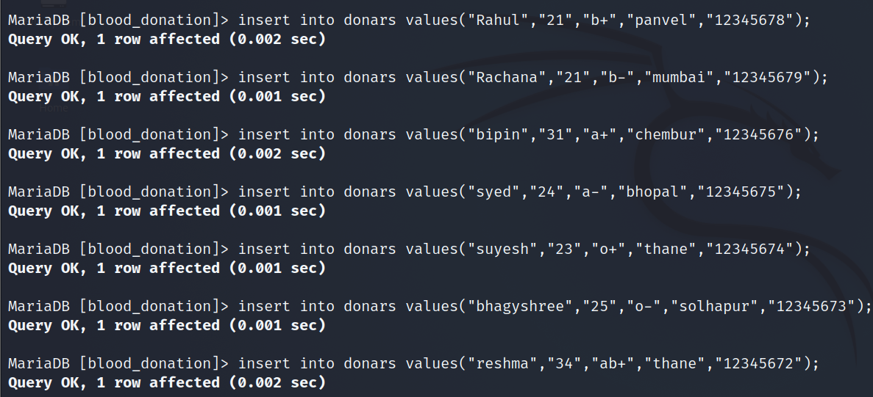

**To check data of tables**

Select * from donors;

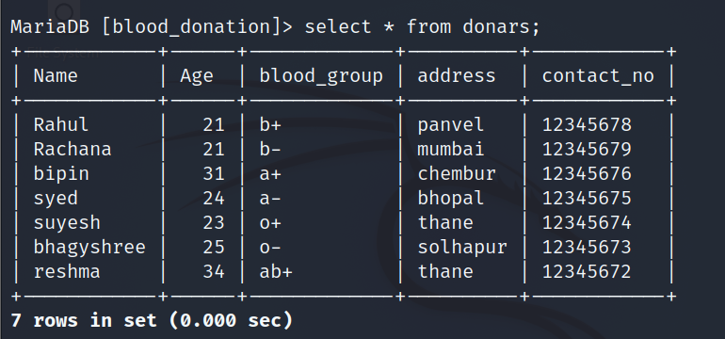

**To find donors from particular address**

Select name .address from donors where address=”thane” ;

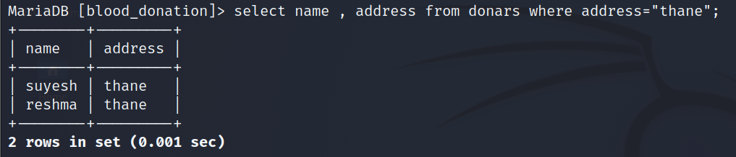

**To alter column name**

Alter table donors change blood_group Blood_Group varchar(5);



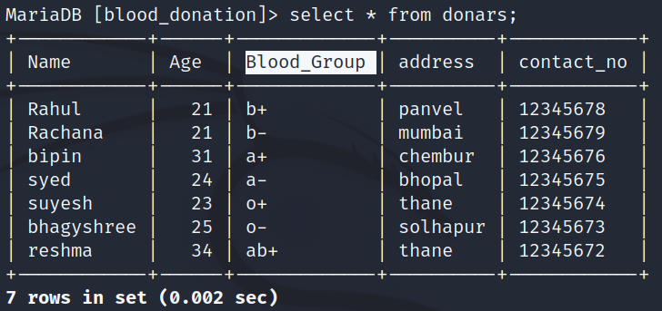

**Delete donars detail by blood group**

Delete from donars where Blood_Groups=”b+”;

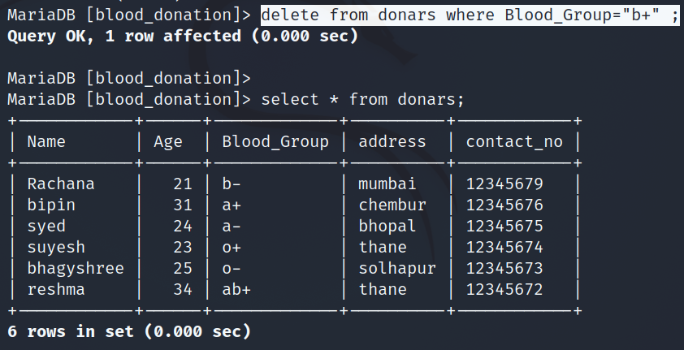

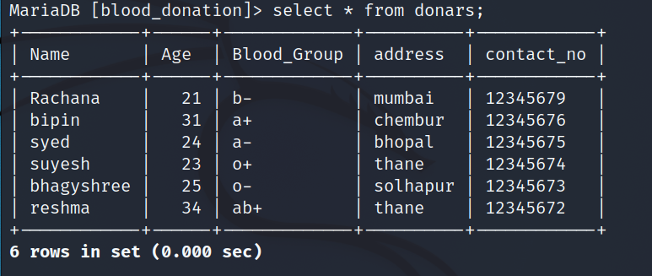

**Update data**

Update donars set address=”dahiser” where Name=”Rachana”;

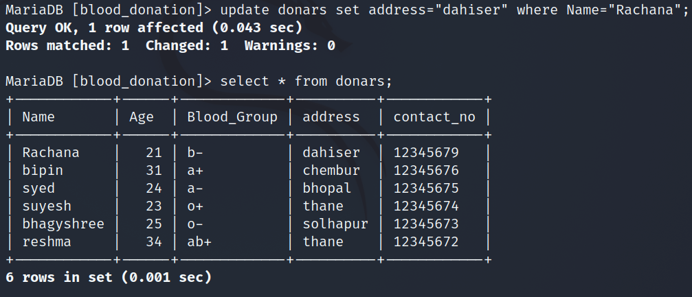

**Table rename**

Alter table donars rename donors;

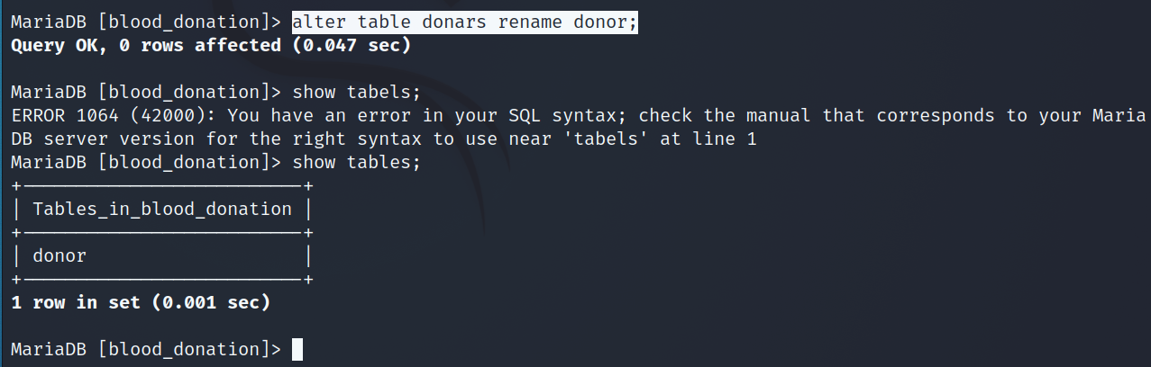

**Drop table**

Drop table donor;

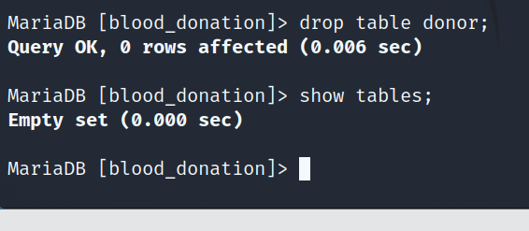

**Drop database**

Drop database blood_donation;

